New Minister’s Information Pack

Presbyterian Church of Victoria
Issue #6, Jan 2019

Please note that this is a general guide only. Complete copies of documents referred to in this booklet, in their latest versions, and the most reliable and up-to-date information, can be found on the PCV website at pcv.org.au under the heading ‘Resources’, or on particular committee websites pcv.org.au/committees/

Table of Contents
Foreword 4
The Call 5
Form of Call 6
Minister’s Leave 7
Minister’s Holiday Accommodation 7
Ministry Family Camp 7
Ministry Wives’ Support and Events 8
Ministry Family Assistance 8
Minister’s Car Loan Scheme 9
Minister’s Retirement Housing Fund 10
Committee Membership 11
Church Membership and Eldership Preparation Booklets 11
Useful Links and Websites 12
Becoming a Marriage Celebrant 13
Safe Church Unit 13
Working with Children Check 13
The Red Book – Risk Management 14
New definitions of congregations and churches 14
The General Assembly of Victoria 16
The General Assembly of Australia 16
Church Courts Flow Diagram 17
Ordination Vows and The Formula 18
Concluding Thoughts 19
A VISION STATEMENT 20

Foreword

If you're a recently graduated Ministry Candidate: congratulations on your perseverance. It seems to take ‘forever’ to be ordained as a minister of the Presbyterian Church of Australia. It begins with mentoring during early years, perhaps a traineeship, followed by four years solid study at the PTC and finally an Exit Appointment where you are a sort-of probationer.

If you're crossing over from another denomination, again: congratulations on untangling some of the web that surrounds the process that leads to acceptance by the GAA Committee. It seems that we place many hurdles in front of you to test your patience!

Perhaps you've recently moved interstate, and are wondering what the principal differences are in church culture and practice here in PCV. If you do find out: please tell me.

Whichever route you've taken - WELCOME into the ministry with PCV.

And this booklet may assist you in finding your feet.

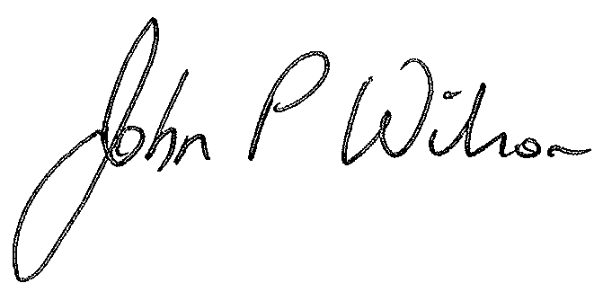
John P Wilson
(Clerk of Assembly)

The Call
At some point in your first year you will, Lord willing, receive a Call to the parish you have been appointed to. To assist you in examining one part of the Call, below is a copy of the Terms of Settlement as presented in the Annual Parish Report that details the remuneration the parish is offering. It may be in financial or calendar year format.
The complete Annual Parish Report is available on the PCV website and can be downloaded at this link: https://pcv.org.au/resources/annual-charge-reports/
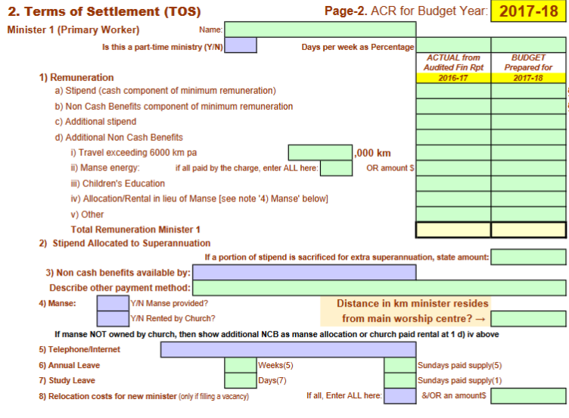

All entries from a) to d) should be filled out, even if it is with a zero or N/A. The stipend and non-cash benefit amounts are decided annually by the General Assembly of Victoria (Remuneration a) and b) entries), while any additional amounts (Remuneration c) and d) entries) are decided by the Board of Management.

As an Exit Student, you should receive 87.5% of the stipend amount set by the GAV and the full non-cash benefit amount. Your Call should include at least the full stipend and non-cash benefit amounts as well as indicating the provision of a manse or manse allowance. The current minimum terms offered are $55,500 per annum, of which the stipend component must be a minimum of $36,324 and the non-cash benefit a maximum of $19,176 (these terms may change from 1 July 2019).

Form of Call

You will also receive a Form of Call along with the remuneration advice. This will appear as follows, in conjunction with the signatures of members and adherents who support the Call:

CALL TO REV ......................................................
We, the undersigned members and adherents of the congregation at ................................................................. in connection with The Presbyterian Church of Victoria, seeking the promotion of the glory of God and the good of the church, being also without a pastor, are well assured of the ministerial abilities, godly character, learning and spiritual wisdom of you ......................................................................... , and we are also convinced of your suitability to our present circumstances.

We have agreed to invite and call you to undertake the office of pastor among us for the promotion of the Christian gospel in our district and for our spiritual welfare. On your acceptance of this call we promise you all due respect, encouragement, and obedience in the Lord, and promise to contribute appropriately to your support as God may prosper us.

In witness of this we have signed this call, as duly attested by:

.......................................... ..........................................
(witnesses to signatures attached at the time of the congregational meeting)
(Normally, the Interim Moderator and Session Clerk)

.......................................... ..........................................
(witnesses to signatures attached afterwards)
(Normally, the commissioners appointed at the congregational meeting)

The Form of Call can be found on page 100 of the PCV Code Book (2019 version). The Code can be downloaded from the PCV website at this link:
https://pcv.org.au/resources/documents/

See pages 18 and 19 of this booklet for the Ordination Vows and The Formula which you will sign at your Ordination/Induction and every subsequent Induction. The Vows and Formula can also be found on pages 113-114 and 117 respectively of the Code Book.

Minister’s Leave
Each year (including your first year) you are entitled to the following:
- 5 weeks Annual Leave to be taken within each 12 months. Such leave is non-accruable. You do not seek permission to take leave, but your session should be notified when you wish to take leave and this must be recorded in the minutes.
- 1 week Study Leave (non-accruable). You need to submit a plan for your proposed Study Leave to your presbytery for approval prior to taking such leave.
- The amount of Sick Leave is unspecified, but you should keep your session informed of any Sick Leave you require, and this must be recorded in the minutes. Following a prolonged absence of 2 months or more, presbytery needs to be involved (see Rule 4.54).

Minister’s Holiday Accommodation
The Board of Investment and Finance administers a holiday housing scheme for ministers. Under the scheme, ministers may apply for one week’s subsidised holiday accommodation per year. This holiday scheme is available only to ordained ministers serving in the PCV including part time (at least 40% load), home missionaries appointed by the Ministry Development Committee, and missionaries (who are set apart by the PCV though not necessarily serving with APWM). The availability of the program is limited by the income generated by the Balfour Memorial Rest Home trust allocated for this purpose and by the demand from eligible users. The day-to-day administration is handled by Ben Palmer who sends application forms to eligible members usually around October each year.
Further details including terms and conditions are available from the BIF downloads page on the PCV website: https://pcv.org.au/resources/bif/ in the document Ministers Holiday Housing policy.

Ministry Family Camp
The Ministry Family Camp is an annual camp run by the Health and Community Chaplaincy Committee, normally held during the second week of the 3rd term school holidays. The camp aims to provide a time of refreshment, teaching, fellowship, fun and encouragement to those who are in ministry in the PCV. Those welcome to attend are ministers (with or without charge, or retired) and their families, as well as ministry assistants, missionaries, candidates for the PCV, church planters, home missionaries and Metro trainees. PYV runs a crèche and programs for children and youth. The schedule also includes free time for fellowship or to enjoy the activities at the camp. The 2019 Family Camp will be held on 30 September – 3 October.

For more information about the camp, please contact Anne Harvey, the HCCC Administrator at hccc.admin@pcv.org.au

Ministry Wives’ Support and Events

The PCV’s Pastoral Support Worker for Ministry Wives, employed by the Health and Community Chaplaincy Committee (HCCC) is available at any time to support and encourage ministry wives. Robyn Johnson, a former PCV and PCNSW ministry wife will commence in the PSW role in early 2018. Robyn’s role is one of confidential and prayerful encouragement and support and she is happy to travel across the state to visit ministry wives wherever they may be based. Once ministry candidate couples know their exit appointments, the PSW will usually seek to schedule a visit, then aim for follow up visits as the wife and ministry couple settle in to their new appointment. These visits are not obligatory in any way; rather, they are planned as an encouragement and support for those who desire it.

Robyn may be contacted at
Phone: 0413 275 555
Email : robyn.johnson@pcv.org.au

The HCCC and Pastoral Support worker also seeks to plan and schedule relevant training and encouragement events for PCV Ministry wives including an annual day conference (PCV calendar permitting) and relevant seminars and activities at the annual HCCC/PCV Ministry Family Camp. These events are advertised well in advance for those involved in ministry within the PCV. Many of our presbyteries also plan their own semi-regular ministry wives get-togethers, depending on interest within the presbytery.

Every year, during Assembly week in October, the Ministry Wives Association holds a special dinner for ministry wives on the Tuesday evening. Invitations are sent out with the Assembly papers in the mail approximately three weeks before Assembly and via the Ministry Wives email loop. In addition, a morning tea and informal lunch takes place for ministry wives during the Commission of Assembly in May every year. For any further information, contact Toni Orchard (Secretary of MWA) at 0409 943 447 or email: ptorchard@bigpond.com

Ministry Family Assistance

The Ministry Family Assistance program provides access to up to four free and confidential short-term counselling services per year for all ministers and home missionaries of the PCV and their families. The program is offered by the Health and Community Chaplaincy Committee. It is a means of helping pastorally care for those in ministry (and their families) and can be used to help in times of personal or ministry difficulty, for family issues, periods of transition or as a general preventative support measure. The service can be accessed by either spouse by contacting Kathy James at chaplaincy@pcv.org.au or Anne Harvey at hccc.admin@pcv.org.au

Minister’s Car Loan Scheme

The Trusts Corporation administers a Car Loan Scheme for ministers. The application form is available on the PCV website: https://pcv.org.au/resources/trusts-corporation/ in the document Ministers Car Loan Application Form but some of the information they provide about the scheme is reproduced below for your information.

When funds are available, the Trusts Corporation is able to make loans to ministers for the purchase of a car to enable them to effectively carry out their ministry. Repayments are made over a period of no more than five years, or before the borrower reaches the age of 65, whichever shall occur first. An administration charge is made (currently $100 at the start of the loan). Interest is payable at the rate of 5% on the balance of the loan. However, the Maintenance of the Ministry Committee provides a subsidy to cover the interest on the first $10,000 of any loan. The interest rate payable on the loan is reviewed annually on the 1st of January and the subsidy is reviewed from time to time.

It is a requirement of any loan granted that the vehicle purchased be comprehensively insured until the loan is fully repaid. Evidence of comprehensive insurance is required to be submitted to the Church Office when the vehicle has been purchased.

The Trusts Corporation makes car loans to ministers for their work in the business of the Church, and so the loans are NOT for predominately personal or domestic purposes.

The Trusts Corporation is not in the business of providing personal finance. If a minister is seeking a personal loan for a second vehicle for his family or other domestic purposes alternative means of borrowing through banks, credit unions and other personal finance companies or advisers must be considered.

Please note that although it is partly funded by a Trusts Corporation Loan, the use of your car is not limited at all, and can be used in any way that you, the owner, determine. However, the Trusts Corporation makes you the Loan on receiving your declaration and on the understanding that the purpose is as declared. If there are reasons to believe that you require the funds for predominantly personal use then the Trusts Corporation must refuse to grant a loan to you.

Minister’s Retirement Housing Fund

Below is an excerpt of the information provided by the Board of Investment and Finance (BIF) in relation to the retirement housing fund provisions.

Introduction
Throughout this document the term ‘Minister(s)’ means any of the following: Presbyterian Ministers
Presbyterian Home Missionaries
Presbyterian Missionaries.

The following Operation Notes have been prepared to inform Ministers, particularly those now nearing retirement, of the nature and extent of the help in the area of housing which, in their retirement, is available from the Housing and Loan Fund. This document is intended to advise and reassure spouses of Ministers of the housing assistance that the Fund may be able to provide, especially for those requiring to leave a Manse following the death of a spouse.

Ministers already in retirement, or their spouses, may also be aided in moving to more suitable accommodation. The Board of Investment and Finance is prepared to consider applications from those who have managed to house themselves but are seeking a smaller or larger or more convenient house, or a house in a different locality.

The Board of Investment and Finance is able to consider offering assistance in some circumstances to separated and divorced spouses of both active and retired Ministers.

The Board of Investment and Finance considers each individual application on its own merits. They may review the financial circumstances of the applicant and, if married, his or her spouse before they determine what, if any, assistance will be offered.

Broadly speaking, there are two ways in which the Board of Investment and Finance may be able to help, either by making available a GRANT to assist with the payment of rent or board or by offering a HOUSING LOAN.

For the complete version of the above document, please go PCV website: https://pcv.org.au/resources/bif/ and download the document Housing Loan Fund Regulations. The application form Ministers Retirement Housing Fund Application is available on the PCV website on the same page.

Committee Membership

The PCV has numerous committees, some of which may approach you regarding becoming a member. In your first year out it is advisable to refuse any such advances to enable you to settle into your parish and give your full attention to it. After your first year, prayerfully choose one area of service (initially) and approach the committee convener to register your desire to serve on that committee. If you need advice on what committees do and where you might best use your talents, speak to members of your presbytery or contact the Clerk of Assembly.

PCV Committees
Australian Presbyterian World Mission (APWM) – Victoria
Board of Investment and Finance
Building and Property Committee
Business Committee
Christian Education and Nurture Committee
Church and Nation Committee
Church Planting Committee
Code and General Administration Committee
Defence Force Chaplaincy Committee
Health and Community Chaplaincy Committee
Maintenance of the Ministry Committee
METRO
Ministry Development Committee
Social Services Committee
State News Committee
Theological Education Committee

Church Membership and Eldership Preparation Booklets

Two booklets are available to aid the preparation of individuals for a) membership in a Presbyterian church and b) eldership in a Presbyterian church. To access these booklets, visit the Christian Education and Nurture Committee website: cenc.org.au under Resources/Downloads/Study Guides.

Useful Links and Websites

Presbyterian Church of Australia | http://www.presbyterian.org.au/
PresKey (online church directory) | http://preskey.org.au/
Presbyterian Church of Victoria | https://pcv.org.au/
PCV Facebook page | https://www.facebook.com/presbyterianchurchofvictoria/
PCV Code Book 2019 | https://pcv.org.au/wp-content/uploads/2018/11/PCV-Code-2019.pdf
Safe Church Unit | http://www.safechurchpcv.org.au/
Australian Presbyterian Magazine | http://ap.org.au/
Australian Presbyterian World Mission (Vic) | http://apwmvic.org.au/
Board of Investment and Finance | https://pcv.org.au/resources/bif/
Trusts Corporation | https://pcv.org.au/resources/trusts-corporation/
Christian Education and Nurture Committee | https://www.cenc.org.au/
Church and Nation Committee | http://yourcan.org/
Church Planting Committee | http://reviveaus.com.au/
Fellow Workers | http://fellow-workers.pcv.org.au/fellow-workers/
Kirkbrae Presbyterian Homes | http://kirkbrae.org.au/
METRO | http://metro.pcv.org.au/
Ministry Development Committee | http://mdcpcv.org.au/
Presbyterian Theological College | http://ptc.vic.edu.au/
Presbyterian Women’s Missionary Union | http://pwmu.org.au/
Presbyterian Youth Victoria | http://pyv.org.au/
Women’s Ministries Victoria | http://wmv.org.au/

Becoming a Marriage Celebrant

Once you are ordained to the ministry, you are eligible to apply to become a Marriage Celebrant under the auspices of the Presbyterian Church of Australia. Write to your presbytery clerk requesting presbytery’s recommendation to the Clerk of Assembly for you to be registered. When you are recommended by presbytery, the Clerk will then nominate you as a Minister of Religion for the Presbyterian Church of Australia. Paperwork will follow.

Safe Church Unit

The PCV provides the Safe Church Unit as a place of resource and assistance for you in your role as a minister in our Church. It is recommended that you take the time to visit www.safechurchpcv.org.au to familiarise yourself with the work and requirements of Safe Church PCV and the Safe Church Unit. Any concerns or incidents relating to abuse that occur within your congregation and ministry or any queries you may have about external reporting or legal responsibilities relating to abuse prevention and response, are to be directed to Fiona Bligh, the Safe Church Facilitator who will be very happy to assist you.

Fiona Bligh may be contacted at 0499 090 449 or email: safechurch@pcv.org.au
For further information you could also refer to the website: http://www.safechurchpcv.org.au/

Working with Children Check

All ministers, elders and volunteers in the PCV require a Working with Children Check card that is registered with the PCV. If you do not already have one, contact Fiona Bligh, the Safe Church Facilitator from our Safe Church Unit (tasked with abuse prevention and response in the PCV) who will be able to guide you through the process as well as assist you with any issues that may arise in relation to the safety of people attending your church.

The Red Book – Risk Management

The Red Book is a manual which assists in monitoring the maintenance of essential safety measures of church property. Each church has been provided with inserts for the Red Book which are tailored to the individual building’s safety needs, as well as a six-monthly schedule of inspections of safety measures. Part of the Board of Management’s responsibility is to ensure that safety maintenance for the building is up to date and that inspections are recorded in the Red Book. When two six-month inspection schedules have been completed, the church will then be issued with an Annual Essential Safety Measures Report which states that the church has complied with essential requirements.

As the maintenance of the Red Book is the responsibility of the Board of Management, the minister is not normally required to be in charge of its upkeep. If you do have questions about the Red Book, however, feel free to contact the PCV Office at office@pcv.org.au.

New definitions of congregations and churches
(from the new PCV Code – 2019 edition)

Because the General Assembly has recently completed a once every two-decade process (writing a new Code), it will be helpful to set out below the new ways in which we speak of congregations and charges:

Congregation, charge, parish and mission field
    - A congregation is a company of people, including children, organised and formed by a presbytery for Christian worship, instruction, fellowship, work and witness.
    - A charge is a sphere of pastoral duty fulfilled by a person authorised by a presbytery and centred on one or more congregations.
    - A parish is the geographic area designated by a presbytery and associated with one or more congregations of a pastoral or appointment charge.
    - A mission field is the geographic area designated by a presbytery and associated with one or more home mission charges or church plant charges.

Types of congregations
The types of congregations are:
- one congregation organised within a parish or mission field under one session; or
- a linked congregation, being one of multiple congregations within a parish or mission field linked by a presbytery under one session; or
- a special interest congregation.

Declaration of a charge
A charge is created by a presbytery declaration immediately following:
- the declaration of the formation of a congregation; or
- the linking of congregations to form a linked charge; or
- the severing of this link to form separate congregations.

Status of a charge
A charge has the status of:
- a Pastoral Charge: a charge normally fulfilled by one or more ministers called by its congregation or congregations, and inducted into it by the presbytery; or
- an Appointment Charge: a charge normally fulfilled by a minister or licentiate appointed to it by a presbytery; or
- a Home Mission Charge: a charge normally fulfilled by a minister, home missionary, or other suitably qualified person, appointed to it by the Ministry Development Committee with the approval of and under the oversight of a presbytery; or
- a Church Plant Charge: a charge normally fulfilled by a minister, church planter, or other suitably qualified person, appointed to it by either the presbytery or the Church Planting Committee with the approval of and under the oversight of a presbytery.

Financial status of a charge
A charge is self-sustaining if it can meet the requirements for the settlement of a minister by call and induction without a grant from the funds of the General Assembly. Otherwise it is aid-receiving.

The General Assembly of Victoria

The General Assembly of Victoria (GAV) is made up of ministers and elders from all charges in the state. It meets for one week in October to receive committee and other reports, and to make decisions for the coming twelve months of ministry. It also deals with any appeals, petitions or overtures that are presented to it. Your attendance is expected (as it is at presbytery unless you are unwell) because ‘to give conscientious attendance upon the courts of the Church’ is part of your ordination vows. A Commission of Assembly meets for one day every May to deal with any business referred to it by the Assembly. One item dealt with at the Commission is to approve committee budgets and the level of ministerial remuneration.

The procedure is generally as follows:
A committee report is taken as read and a motion to receive it is moved and seconded. Clarifying questions of the report may be asked prior to the motion being voted on. Once the report is received, the deliverance is spoken about. The deliverance is what a committee itself puts forward to direct the work of the committee in the year ahead. Depending on the nature of the deliverance, it may be passed ‘as a whole’, or it may be dealt with clause by clause or in groups of clauses. Each clause can be altered by the Assembly. Refer to the PCV Code Chapter 7 (particularly Sections Two to Six) for further detail on Assembly procedure.

The General Assembly of Australia

The General Assembly of Australia (GAA) is made up of representatives from each State Assembly and presbytery. It meets for one week in September every three years in Sydney and proceeds in a similar way to the GAV by receiving reports of its committees, deciding upon the deliverances put before it, and dealing with any appeals, petitions or overtures submitted to it. The next GAA will commence on 9 September 2019.

In the first week of February each year, the committees of the GAA meet in Sydney. The meetings are scheduled over the space of a week so that the Moderator General and Clerk of Assembly can attend most meetings. This Annual General Meeting sets the agenda for each committee for the coming year and deals with any issues that have arisen in the course of the preceding year and need the attention of the full committee. Most committees have executives that meet a number of times during the year to deal with emergent issues.

On the following page is a flow diagram of the church courts of the PCA.

Church Courts Flow Diagram

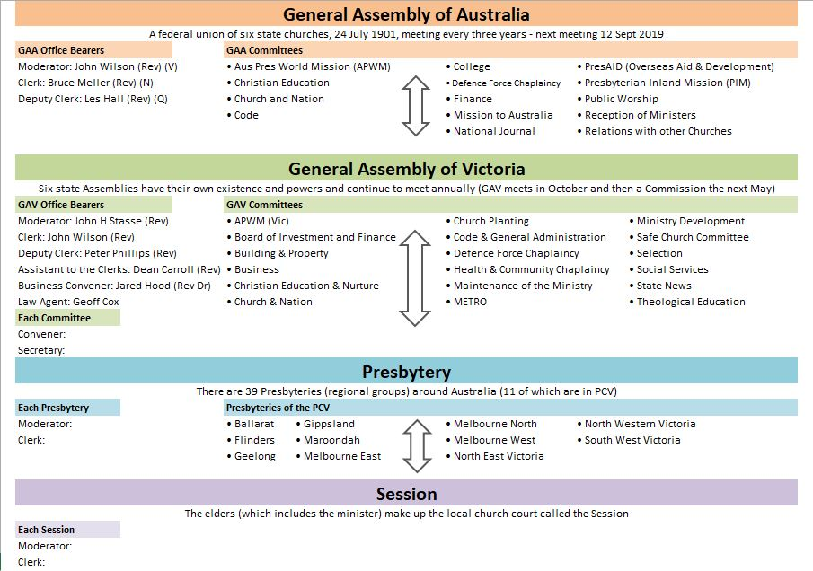

Ordination Vows and The Formula
When you are ordained and inducted initially, and at any subsequent Induction, you will be expected to answer affirmatively to the nine questions listed below. Following such affirmation you will be asked to sign The Formula that is a summary of the Vows. The questions asked of the congregation at an Induction precede the minister’s vows.

Questions at ordination/induction of ministers
Questions for the congregation, which is invited to stand:
(Normally assent is given by the congregation answering together: ‘We do’.)

- Do you, the members and adherents of this congregation, adhere to the call which you have already signed in favour of Rev ..................................... to be your minister?

- Do you now warmly receive him as your minister, promising to provide for his suitable maintenance, and give him all due respect, encouragement and obedience in the Lord?

Questions for the minister‐elect:
(Assent is given by the answer: ‘I do’ for all questions except the 5th (question e) which is answered: ‘They are’)

- Do you believe the Word of God which is contained in the Scriptures of the Old and New Testaments to be the only rule of faith and practice?

- Do you own and accept the Westminster Confession of Faith, as amended by the General Assembly, read in the light of the Declaratory Statement contained in the Basis of Union adopted by this church on the 24th day of July, 1901, as an exhibition of the sense in which you understand the Holy Scriptures and as a confession of your faith; and do you engage firmly and constantly to adhere thereto, and to the utmost of your power to maintain and defend the same?

- Do you own and accept the purity of worship as practised in this church?

- Do you own the Presbyterian form of government to be founded on the Word of God and agreeable thereto; and do you promise that, through the grace of God, you will firmly and constantly adhere to, and to the utmost of your power, in your station, assert, maintain and defend the same?

- Are zeal for the glory of God, love to the Lord Jesus Christ, and a desire to save souls, and not worldly interests and expectations (so far as you know your own heart), your great motives and chief inducements to the work of the holy ministry?

- Do you accept this call and promise through grace to perform all the duties of a faithful minister of the gospel among this people?

- Do you promise to give conscientious attendance upon the courts of this church, and to direct your best attention to the business thereof, doing all in the spirit of faithfulness, brotherly kindness and charity?

- Do you promise, in the strength of divine grace, to lead a holy and circumspect life, to rule well your own house, and faithfully, diligently and cheerfully to perform all the parts of the ministerial work to the edifying of the body of Christ in love?

- All these things you profess and promise through grace, as you shall be answerable at the coming of the Lord Jesus Christ?

Formula for ministers and elders
I own and accept the subordinate standards of this church, with the explanations given in the articles contained in the Declaratory Statement, as an exhibition of the sense in which I understand the Holy Scriptures, and as a confession of my faith. I further own the purity of worship practised in this church and the Presbyterian government thereof to be founded on the Word of God and agreeable thereto; and I promise that through the grace of God I shall firmly and constantly adhere to the same, and to the utmost of my power shall, in my station, assert, maintain and defend the doctrine, worship and government of this church.

Concluding Thoughts
If you have any further enquiries, you are welcome to contact the Clerk of Assembly, John P Wilson, on 0418 537 209. Suggestions for improvements for subsequent editions of this booklet would be welcome and can be forwarded to the church office email at office@pcv.org.au.

A VISION STATEMENT
OF THE PRESBYTERIAN CHURCH OF VICTORIA

Summary vision statement
By God’s grace we exist to glorify and enjoy God through worship, teaching God’s word, evangelism and social interaction, always in the light of the inspired Scriptures and relying on God’s presence, power and wisdom.

As part of the redeemed people of God, having been brought out of darkness into God’s light through faith in Jesus Christ, the Presbyterian Church of Victoria seeks to glorify and enjoy God – as Father, Son and Holy Spirit – serving, loving and obeying him, in the light of his revealed Word, the Bible.

The Presbyterian Church of Victoria holds the Bible to be the inspired and inerrant revelation of God, a book fully trustworthy to guide the Church in all matters of faith and practice. Embracing this particular view of inspiration of scripture means that our work and witness has distinctive guiding values, these being expressed in what is known as:
- reformed doctrines and church practice
- the confessional position of the Westminster Confession of Faith (1647).

We seek to serve and obey God by:
- worshipping God in Spirit and truth;
- edifying God’s people, by teaching God’s Word, in order that they become mature in Christ, living a holy life;
- evangelising the lost through proclaiming and living the gospel;
- engaging in social witness, demonstrating God’s love and righteousness in both word and deed.

By being faithful in these things it is our passionate prayer that, by God’s grace:
- lives will be changed according to the pattern of Christ’s life;
- there will be growth and maturity in existing churches;
- the unsaved will come to faith in Christ;
- new churches will be planted;
- and in all this, churches will have an effect in changing society’s values for good.

In pursuing this mission we seek to:
- depend at all times on God’s leading;
- be aware of the culture in which we minister;
- be prepared to take bold steps to fulfil this mission in the State of Victoria, throughout Australia and toward all parts of the world.

