Instructions for Multi-Congregation APR (APREM)
CONTENTS
Instructions for Multi-Congregation APR (APREM) 1
1. Introduction 2
1.1 APREM Cells 2
a) Light Green Fields 2
b) Light Blue Fields 2
c) Yellow Fields 2
d) Pink fields on ‘WHOLE PARISH Financial Summary Page’ 2
e) Green Comment fields 2
2. Overview of the APREM Financial Pages 2
3. Annual Parish Report Page One (APR_pg_1) 4
3.1 Budget Period Identifies the APR 4
3.2 Select Presbytery, Parish & Church 4
3.3 Enter the Congregation Names 4
3.4 Timetable of events 4
3.5 Statistical Information 4
4. Terms of Settlement (TOS) (APR_pg_2) 4
4.1 Page 2 Notes 4
4.2 Additional Workers 5
4.3 Relocation Costs 5
4.4 Calendar Year 5
4.5 Page 3 Notes 5
4.6 Column Labelling 5
4.7 Field (Cell) Referencing 5
a) Data Entry 6
b) Term Deposits/Investment Assets (Unreserved). 6
c) Reserved and Fixed Assets. 6
d) Insurance Cover Values 6
e) Date Auditor Signed Report 6
5. Comments and Authorization Page 4 (APR_pg_4) 6
5.1 Page 4 Notes 6
6. APR Form - Process of Completion and Approval 7
6.1 Procedural Notes 7
6.2 Urgent Annual Parish Reports from Un-Audited Data 7
7. Printing the APR Form and saving as a PDF 7
8. Using Last year's completed APRE 8
8.1 Safely keep previous year APR (APRE) 8
8.2 Copy and Rename File 8
8.3 Modify, Copy, Clear and Enter Data Appropriately 8
9. Board of Management 8
10. Congregational Meeting 8
11. Extra Features 8
11.1 Comments 8
12. Appendix 9
a) Specific Cell (C5a) Balance Calculation example. 9
b) General Balance Calculation 9

Introduction
Each year, the Annual Parish Report (APR) is prepared from audited annual financial reports for the two financial periods just prior to the budget financial period (which identifies the APR). It includes statistical and other financial data, along with Terms of Settlement able to satisfy the financial requirements of the General Assembly of Victoria as administered by the Maintenance of Ministry Committee (MMC) and Presbyteries.
The purpose of the report is to:
a) assist Presbyteries in their oversight of congregations and
b) enable Maintenance of Ministry Committee to declare the Terms of Settlement and supply relevant data to other Committees of the Assembly.
Some parishes have made spreadsheet versions to help them fill in the form and improve accuracy and legibility.
This multi-congregation version is designed to be filled in electronically and will be referred to in this document as APREM (E for electronic, M for Multi-). When finalized, the printed output is the APR. It can still be printed with blank data and used as a manual version, but these instructions are made with computer entry of the data in mind. Using the APREM on a computer is recommended.
Note: A lot of effort has been undertaken to produce instructions that are correct and up to date. Please notify the Registrar of the Maintenance of Ministry Committee if any irregularities are discovered.

APREM Cells
Using Microsoft Excel, the APREM appears on screen and consists of 7 or 8 pages with information fields (or cells) in rows or lines for computer data entry. Screen entry is intended to work on Excel 2003 and higher. This 2015 version now appears to work fine in the latest versions of OpenOffice 'Calc' and LibriOffice ‘Calc’ whereas previous versions did not.
Note: All the white area or cells are non-editable.

Light Green Fields
The fields (or cells) where information can be typed in are coloured light green.

Light Blue Fields
There are light blue fields which are drop down boxes where the input data is selected from one of the items in the drop down list.

Yellow Fields
The fields contain formulas and are not editable.

Pink fields on ‘WHOLE PARISH Financial Summary Page’
The fields contain formulas and are not editable.

Green Comment fields
Please note that there are some larger green fields which are text entry fields for entering descriptive/information data (ie. comments). When entering data in these text fields, the text will automatically wrap and to force a new line, hold the Alt key (on PC) down and press Enter.
Green Comment fields

Overview of the APREM Financial Pages
The financial pages consist of 4 or 5 pages depending on whether there are two of three congregations in the parish. Figure 1 is a diagram representing the various financial pages.
All the headings a set automatically from entries made on page 1 – notably the yellow column headings and the red congregation names. Each data item entered (green fields) on the congregation pages is added forward (or upward in diagram) to the ‘WHOLE PARISH Financial Summary Page’. Exceptions are for transfers in to the ‘FEDERAL BOARD Financial Summary’ Page [or out to local congregation(s)]. See Figure 2.1 which illustrates how the spreadsheet pages work together.
Figure 2.1
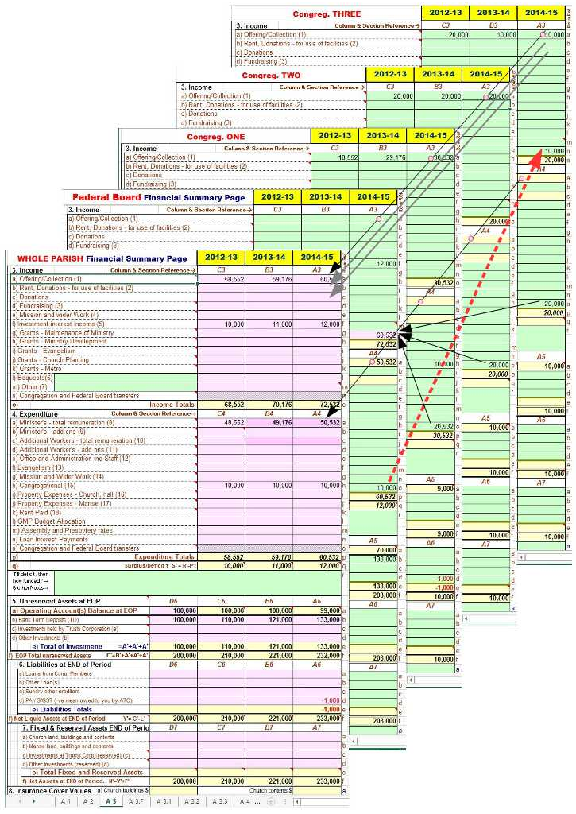
Note the naming of the sheets ie. A_1, A_2, A_3F, A_3.1, A_3.2, A_3.3, A_4. Also note that A_3.1, A_3.2, and A_3.3 are next to green fields on page 1. The congregations names entered on page 1 (see Figure 3.1) correspond to these sheets and appear at the top of the respective sheet.
Also, if there are only two congregations in the parish then sheet A_3.3 can be hidden by right clicking on the sheet tab and selecting ‘Hide’. It can also be un-hidden by right clicking on any tab and selecting ‘Unhide’.
Further, Federal Board transfers occur between local congregation pages and the ‘FEDERAL BOARD Financial Summary’ Page and do not appear on the ‘WHOLE PARISH Financial Summary Page’.

Annual Parish Report Page One (APR_pg_1)
Figure 3.1
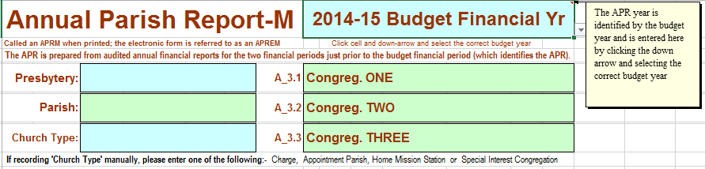

Budget Period Identifies the APR
The budget period is entered in the top right blue field using the ‘drop-down’ arrow that appears when the field is clicked. See figure 3.1, "2014-15 Budget Financial Yr"; entry example for a financial year.
If you do a 'mouse-over' this blue cell, the following comment is displayed:
“The APR is identified by the budget year and is entered here by clicking the down arrow and selecting the correct budget year”.
All throughout the APREM, the darker yellow fields contain an appropriate Financial Period and are automatically set from this field entry. Note: All yellow fields are non-editable.
**Apart from the blue ‘drop-down’ fields, the green cells or fields are the only ones for data entry.**

Select Presbytery, Parish & Church
Also, figure 1 shows the Presbytery drop down box. All drop down boxes are coloured blue. First, click on the blue field and a small box appears to the right of the field with a small triangle pointing down. Second, click on this triangle arrow and the drop down box opens. Click on the selected line item and that item then appears in the blue box as entered data.
The other drop down box (blue box) on page-1 is to select the Church type. Select the correct one for your church.

Enter the Congregation Names
There are three green fields prefixed with A_3.1, A_3.2, and A_3.3 respectively: Enter the congregation names here. If only 2 congregations, then leave the green field next to A_3.3 blank. Also, page A_3.3 should be hidden (see section 2 above).

Timetable of events
Please observe the timetable of events listed on page 1 as appropriate for your church's calendar or financial period for completion of the APR.

Statistical Information
This section is fairly self-explanatory and except for the "Kms from Manse", the data entered should exactly match the data reported in the "Annual Statistical Returns" for the most recent calendar year.

Terms of Settlement (TOS) (APR_pg_2)

Page 2 Notes
This page is to record the remuneration paid* and related TOS items. The minimum stipend* and NCB* amounts entered are not to be less than those set annually by the General Assembly of Victoria. Normally, the audited amounts paid are entered in the 'ACTUAL …' column and the proposed budget amounts in the 'BUDGET …' column. There are other fields to complete including fields with drop down boxes to select the input.
Also remuneration lines d) iv): If a minister is paid in lieu of a manse then enter this amount or is provided with a non-church owned manse rented by the church then enter this rental amount.
This page also contains space to add the Terms of Settlement of a second minister.
*Congregations of all Parishes using a calendar year, need to authorize their Boards of Management to adjust the Terms of Settlement in the middle of their financial year in line with the new TOS set by the GAV to commence on 1 July of that year.
Please note that the light yellow fields automatically total the column inputs and transfer the respective totals automatically to A_3.F at A4a and B4a. [The reference A4a refers to column A4 in the '4.Expenditure' section and the row labelled 'a', and hence B4a is the adjacent cell in column B4 of the same row labelled 'a']

Additional Workers
For additional workers, note the line "Additional Worker(s) - Print this page, fill it in, and add the totals to these fields" at the bottom of the page 2. Do simply what the line says, ie. print the page with all fields blank, fill in the printed copy, calculate totals manually and enter appropriately on that line. Attach any additional sheets with the APR (ie.the printed APREM).

Relocation Costs
Where a parish is vacant, a minister is normally budgeted for, including an estimate for ‘relocation costs’ so the congregation will know its ability to call a minister. Do not forget to include the relocation costs in the budget including an estimate where 'ALL' is entered as the response to the relocation costs. The budget amount is to be manually added to the ‘Congregational’ total on the ‘FEDERAL BOARD financial summary page’ at A4h. The figure is for budgeting only – a note in the comment field (A4r) should be made (eg. “Re-location of $4,000 added to A4h”).
It is standard practice that all moving costs are met by the parish.

Calendar Year
*Congregations of all Parishes using a calendar year, need to authorize their Boards of Management to adjust the Terms of Settlement in the middle of their financial year in line with the new TOS set by the GAV to commence on 1 July of that year.

Page 3 Notes
Figure 2 is a copy of the top portion of the Financial Summary Page for Congreg. ONE
Figure 2 | 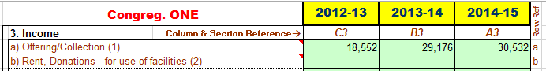
The darker yellow fields are calculation fields and are non-editable as are all the white areas (cells) of the page. ***The green cells or fields are for data entry***

Column Labelling
For each of the financial summary pages, the columns are labelled with the capital italic letters A, B & C in sections 3 and 4 and an additional column D in sections 5, 6, 7 &8. In each section, the section numbers in italics are added.

Field (Cell) Referencing
For each of the financial summary pages, there are six sections (3, 4, 5, 6, 7 & 8) and each section row begins and ends with a, b, c, etc. Field referencing uses the column letter in capitals, the section number and row letter in lower case. For an example if one was considering the budget (column A) expenditure figure for evangelism, then the reference to the correct field or cell would be 'A4f'.

Data Entry
In the income and expense sections, enter for each column period (columns B & C) the transaction totals for each line or row item. If your account software (or manual financial books) is set up correctly, the values can be transferred directly from the section heading amounts as listed in the summary printout of your income and expenditure statement (or profit and loss statement).
Budget figures (Column 'A') are estimated from previous history, anticipated works/maintenance and other targets set by Board and Session. Significant budget amounts should have an added note.
Items on lines 3l and 3m have green text entry field for addition entry of small notes.
The larger green field, with "† If a deficit, how funded? and other notes→” beside it, is a text entry field for any pertinent notes, particularly to note how a deficit is to be funded or other note concerning a notable entry value. Text will wrap automatically, but to force a new line (on PC) hold the 'ALT key' down and press 'Enter'.
Below section 4 there are four sections each with four columns, the extra column is labelled 'D'. You can think of these columns in two way:
i) the ending figures for the financial period just completed (EOP).
ii) the beginning figures for the next financial period.
The 'D' column figures are the End of Period (EOP) amounts for the financial period just prior to the 'C' column period and are the beginning amounts for background calculations for all the year periods represented by columns C, B & A.

Term Deposits/Investment Assets (Unreserved).
Term deposit and investment asset amounts, each including interest, are entered for each EOP to the appropriate cells in rows 5b, 5c and 5d. The corresponding interest amounts are entered to the appropriate cells in the income section ie. f) Investment interest income (5) or more briefly, to row 3f.

Reserved and Fixed Assets.
The fixed asset amounts are entered in rows 7a and 7b.
Please note rows 7c and 7d are listings of EOP reserved asset account totals. If due permission to use interest from a reserved asset account is obtained then the interest is added to the appropriate column in section '3' and row 'f'.

Insurance Cover Values
Section 8 at the bottom of the sheet is for entry of the current Insurance Cover Values for the properties. Insurance cover (with regular reviews) should be maintained at all times.

Date Auditor Signed Report
After auditing of the Congregation’s financial books, the date the Auditor signed his/her report is entered at the very bottom of the Financial Summary Page (page 3). Ie. a date for each of the financial periods represented by columns B, C and D.

Comments and Authorization Page 4 (APR_pg_4)

Page 4 Notes
This page contain remarks/comments from the parish, Moderator/Interim Moderator, Presbytery and finally the Maintenance of Ministry Committee. Their respective signature sealing the authorizations and actions in each of the sections 9, 10, 11 & 12.. The green fields are for data entry and the blue ones for data entry by selecting from the drop down selection boxes.
Board of Management and Congregation approval is required. When making urgent applications please observe the guiding note under the section 9 comment field.
“Please indicate if this application is URGENT and if column B (pg.3) is estimated (ie.not an audited report), then include the number of months of real data the estimates are based on. Non-urgent APRs are prepared (columns B &C) from audited financial reports.”
This form is normally approved by the Board of Management (Session Clerk if no Board) - name, signature & date indicates approval.
Also, the note appended at the end of section 9 is to indicate what signing of the report means.
“This form is normally approved by the Board of Management (Ses Clerk if no Board) - name, signature & date indicates approval. This approval implies a declaration, to the best of knowledge, that the summary financial information included truly correlates with the congregation's audited annual financial reports and based on these figures a reasonable budget was prepared (column A).”
A further note is appended at the end of section 10 to indicate what the Moderator/Interim Moderator’s signature means and reproduced as follows:
"The Moderator's signature is confirming the Congregational approval of the terms of settlement”
The date of the congregational meeting is required information. For multi-congregation parishes, could the Moderator add dates of approval by other congregations.

APR Form - Process of Completion and Approval

Procedural Notes
At the end of the financial period, the annual financial and APR reports are prepared and after auditing of the financial report, the APR is finalized with a budget for the budget year. At the Annual Congregational Meetings (AGMs), the audited financial report is received, presented to the congregations, and adopted (assuming the report is satisfactory). At the same meeting a reasonable budget is presented which includes the terms of settlement for current minister(s) or possible minister (ie. vacant parish) are received. After being presented and found satisfactory, it is approved by each congregation either at separate meeting or a combined congregation meeting. The congregation can delegate the power of approval for the terms of settlement to the Federal Board of Management for a current settled ministry in the Parish, but not the proposed budget. [Calendar year congregations should delegate power to the Federal BOM so that mid-financial-period adjustment to the TOS can be made according Victorian General Assembly resolutions]
After approval by the Congregation(s) and signature of the Moderator/Interim Moderator, Presbytery reviews the information in the form to see that the Congregation can meet their commitments and gospel work maintained. Presbytery has the power to call for explanations or more information as the case may be, before approving the APR and forwarding it to the Maintenance of Ministry Committee (MMC). The MMC also reviews the form contents and may instigate questions and information from both Presbytery and Congregation before being satisfied that the Congregation(s) listed on the form can adequately support their minister and the ministry in their parish. When the MMC is satisfied concerning an APR form it is formally declared and reported to Presbytery and the Parish (using the church address supplied in section 9).

Urgent Annual Parish Reports from Un-Audited Data
When situations arise and urgent APRs are prepared for submission to Presbytery (eg. for an urgent grant application to the MMC) from un-audited data, it is important to realise that this does not replace the routine annual process of preparing an APR using the audited financial statements from the just completed financial period and following the approval process via Presbytery to the MMC.

Printing the APR Form and saving as a PDF
At the appropriate time, print the APREM. The printed document is the APR. On page 1, scroll down to reveal the print instructions. Single, multiple pages or the whole document can be printed but the XL version may alter some parts of the following:
To Print the APR - hold down 'Ctrl' key and press 'P' key or 'Ctrl' and 'F2'
(Note: Your print window may vary depending on your printer but the following selections may apply)
*Select Printer (if more than one printer)
*Under settings select 'Print Active Sheets' or 'Print Entire Work Book".
*If more than one page and less than 4 pages, then with the "entire workbook" selected (as in previous) enter the
page numbers in the from and to boxes and click OK. Eg. entering 2 and 4 will print pages 2, 3 & 4.
*Select 'Print on Both Sides' (this selection will not show if printer does not have this ability) or 'Print One Sided'.
*'A4' 'Portrait Orientation' and 'Fit Sheet on One Page' should already be selected.
*Click print button (and if another print dialog come up - click 'Print' or 'Start Printing' - depends on printer)
For Excel versions later than 2003, the APRE can be saved as a PDF file.
Just under the above instructions there are instructions to save the APRE as a PDF file.
Briefly, pressing keys “Control and then ‘P’” brings up the print dialog window. Click ‘Export’, then click the ‘Create PDF/XPS Icon’. A publish as PDF or XPS dialog window opens, click the ‘Options…’ box lower middle of window and another little ‘Options’ dialog window opens, click ‘entire workbook’ button and optionally select pages to include. Then click ‘OK’ and it closes. Change filename as appropriate and click ‘Publish’ – and take note of where the PDF file is saved to.

Using Last year's completed APRE

Safely keep previous year APR (APRE)
This applies particularly to the Financial Summary Pages.
Make sure your previous year's finalized and approved APRE is safely kept, preferably in two places (one copy on and another off the computer eg USB key or drive and keep in a safe place). Write protect the finished files.

Copy and Rename File
Then for the current year make a copy of the previous year's file (renaming the file appropriately).

Modify, Copy, Clear and Enter Data Appropriately
Using the copied and renamed file, modify the data on each of the pages as concerning the current year.
Do the following for each congregation’s financial page and the Federal Board Financial page.
Make sure all fields are considered and using a printout of the various financial pages:
Manually transfer the data in the following yellow cells as these do not copy.
B4a to C4a; B4c to C4c(Federal Board page only) and C5a to D5a (for Federal and all congregational pages). Refer to previous year’s APR printout when doing the yellow cell transfers as they quickly change due to automatic calculations built into the APRE.
For section columns B3 and B4 green cells, copy and paste to columns C3 and C4 respectively. Continuous green columns of cells can be copied and pasted. Yellow cells will not.
For sections 5, 6 & 7, move these column values one column to the left.
Then clear the figures in columns B and A. Enter actual figures into column B from the audited financial report (under some circumstances estimated whole year figures are used). Enter the date the Auditor signed his/her report in the bottom field of the column.
Then fill in the figures for the budget year in column A.
The background calculations run in the background and do instant recalculations. Any changes in columns D, C, B instantly change some values in column A (and other column values on the way).

Board of Management
The Boards of Management should consider the APREM (or printed form which is the APR) and approve by resolution that it reflects the audited financial statements of the respective congregation and that it contains a reasonable budget for presentation to a congregational meeting.

Congregational Meeting
Each year, each congregation considers and if in order, receives and adopts the annually audited financial statements, approves the APR containing the terms of settlement and its budget that the Board of Management has previously considered and approved.

Extra Features

Comments
Due to compatibility issues, the ability to "Turn Comments ON or OFF" has been removed.

Appendix
Most of the yellow fields are summation fields, normally summing the figures immediately above them. The fields C5a, B5a and A5a calculate their contents as follows:

Specific Cell (C5a) Balance Calculation example.
The C5a Balance is calculated as follows:
C5a=D5a+C4q+D5e-C5e+C6e-D6e ie. The bank balance at the end of this financial period

General Balance Calculation
Or as a general description for each of the fields C5a, B5a and A5a as follows:
This EOP operating account(s) balance EQUALS Last EOP Operating Account(s) balance
PLUS any surplus/deficit for this current period.
PLUS sum of last period's EOP investments MINUS sum of this period's EOP investments
PLUS sum of this period's EOP liabilities MINUS sum of last period's EOP liabilities

